**PWM controlled Centre of mass**

**Abstract**

controls a hobby gear motor to balance an object on a scale-like setup by adjusting its position based on distance measurements from two ultrasonic sensors. The sensors measure the distances on both sides of the object, and the code calculates the difference between these readings. Based on this difference, the motor moves either left or right to compensate for the imbalance.

When the difference between the distances is large, the motor moves with higher speed to make significant adjustments. As the difference decreases, the motor speed reduces, allowing for finer adjustments. Additionally, when the distance difference is small, the motor rotates by smaller angles to ensure more precise balancing. This helps prevent overshooting the balance point. The system continuously monitors the distance readings and adjusts the motor’s speed and movement direction accordingly. Once the difference reaches zero (i.e., the object is balanced), the motor stops, and the loop pauses.

Delays between movements allow for controlled adjustments, ensuring that the object is balanced smoothly and accurately.

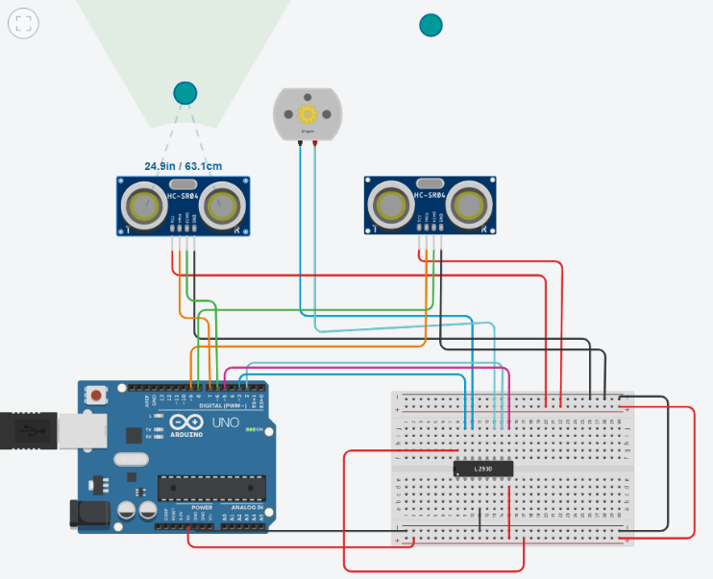

U

U

**PWM control signals in code**

PWM (Pulse Width Modulation) control signals, as utilized in the code, control the speed of the motor by varying the duty cycle of a signal. The duty cycle represents the percentage of time the signal stays "ON" during a given period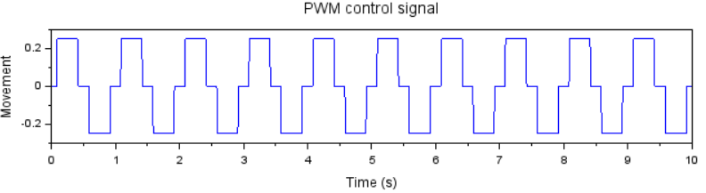we use reduced speed in the next positive clock with fix motor delay as to reduce motor rotation angle for we are using mapping difference of distance in speed.

**int speed = map(abs(difference), 0, 30, 0, 255);**

For generating the PWM signal, where the speed value (ranging from 0 to 255) adjusts the motor speed. The higher the value, the faster the motor moves; a lower value makes the motor slower.

**analogWrite(enablePin, speed);**

**Hardware model**

